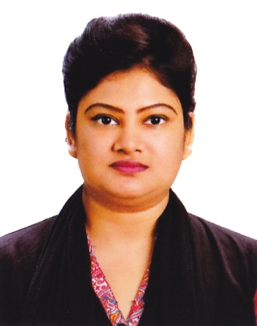**Dr. Mahbuba Haque**

04-A, Agrani Apt, Elephant way,

104/01/ka, Baro Moghbazar,

Shantinagar, Ramna, Dhaka-1217

Contact phone: 01911-421997 (Res)

Contact phone: 01914-207303

E-mail:mahbubahaque56@gmail.com

**OBJECTIVE**

Have a desire to render more service for all kind of people and humanity where my interpersonal knowledge, education and ability to work in a dynamic environment and will be effectively utilized to obtain a challenging position in a fast paced medical institution/organization.

**SUMMARY OF SKILLS**

* Have successfully completed the internship from **Holy Family Red Crescent Medical College.**
* Having MBBS from **Holy Family Red Crescent Medical College**.
* Strong command over computer.
* Strong interpersonal communication skill
* Creative, honest and enthusiastic in challenging working field

**EXPERIENCE**

**Internship Training**

**Holy Family Red Crescent Medical College.**

November 27,2010 to November 26,2011

Detail:

|  |  |  |  |
| --- | --- | --- | --- |
| Placement | Duration of training | | Total week |
|  | From | To |  |
| Surgery | 27.11.2010 | 08.04.2011 | 19 week |
| Obstetrics & Gynecology including community placement | 09.04.2011 | 15.07.2011 | 14 week |
| Medicine | 16.07.2011 | 26.11.2011 | 19 week |

**EDUCATION**

**M.B.B.S-2010**

**Holy Family Red Crescent Medical College**

Successfully completed

**H.S.C (Science)-2004**

Chittagong Public School & College

Chittagong Board

GPA-4.70

**S.S.C (Science)-2002**

Dr. Khastagir Govt Girls High School, Chittagong,

Chittagong Board

GPA-4.63

**PERSONAL INFORMATION**

Date of Birth : November 09’ 1987

Nationality : Bangladeshi (By Birth)

Religion : Islam (Sunni)

Marital Status : Married

Husband Name : Mohammed Khayam Faruqui

Father’s Name : Md. Obaidul Haque

Mother’s Name : Nazma Akter Chowdhury

Permanent Address : 04-A, Agrani Apt, Elephant way,

104/01/ka, Baro Maghbazar,

Shantinagar, Ramna, Dhaka-1217

**SKILLS**

**Language Skills:**

* Sufficient knowledge over written and verbal communication in English.
* I have been working as a honorary medical officer in the department of skin and VD, BIRDEM, Shahabag, Dhaka since July, 2015.

**REFERENCE:**

1. Prof. Dr. Mir Nazrul Islam, deptt. Of skin & VD, BIRDEM, Shahabag, Dhaka, Cell no: 88-01711-595551.
2. Associate Prof. Dr. Hosne Ara Begum, deptt. Of skin & VD, BIRDEM, Shahabag, Dhaka, Cell no: 88-01711-434771

Trust the above will be found in order to consider my case to appoint me which help to proof my efficiency and obliged thereby.

Sign.jpg

**Dr. Mahbuba Haque**

Cell no: 88-01911-421997 # 01914-207303

Res: 88-02-9340349

Date: 28.12.2015